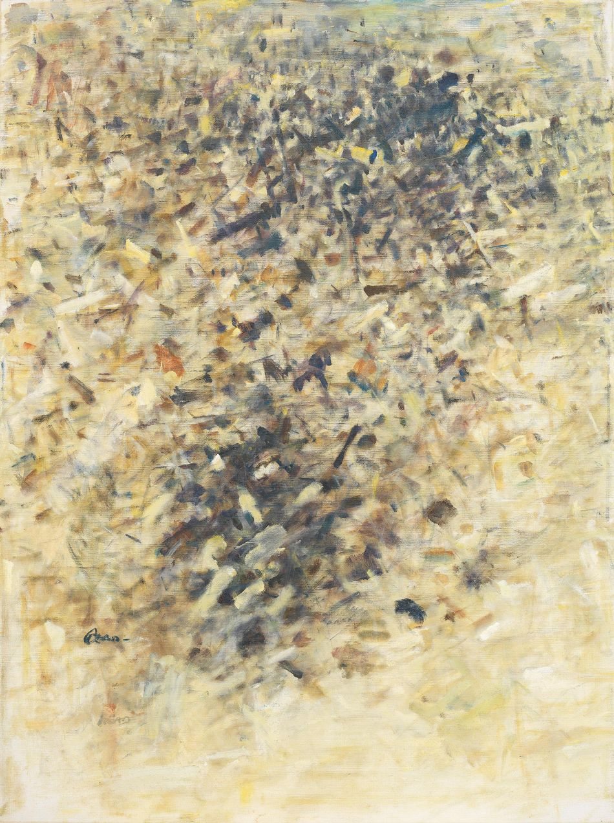

李德 Reed Lee，在天之涯In a Faraway Place，1983，oil on canvas，130 x 97 cm

**另一片天空的異國雲彩 － 關於抽象**

A Foreign Cloud in Another Sky：Taiwan Abstraction from 1960’s

**陳庭詩 Chen Ting-Shih 陳德旺 Chen DeWang 許雨仁 HsuYuJen 李德 Read Lee**

**林亦軒 Lin YiHsuan 楊乃臻 Yang NaiJen**

***2025年4月15日至5月24日***

Each Modern亞紀畫廊欣然宣布4月份群展「另一片天空的異國雲彩 － 關於抽象」，由獨立於主流體系外的陳德旺、陳庭詩開始，著眼於超越既有型態與美術院校的先鋒抽象藝術家：李德、許雨仁、林亦軒、楊乃臻。此展對應同期金車文藝中心南京館舉辦的「凝視他方的旋轉小路－關於寫實」，是亞紀畫廊以二十一世紀的角度對台灣戰後與當代藝術的重新詮釋與推薦。

1948年紐曼Barnett Newman在其文章〈崇高就是現在 The Sublime Is Now〉，提出了關於崇高與藝術的深刻問題。他質疑，在一個缺乏崇高傳說或神話的時代，藝術如何能夠創造出崇高的作品？在西方藝術與宗教的共同發展史中，崇高一直是重要討論的主題與精神，但也意味著藝術因此被已過度思考、書寫、描繪或社會化的東西引導、影響了對未被充分理解面向的探索。也因此，當任何藝術對「藝術是什麼」這一問題提出質疑時，往往遭受壓抑：在1930到50年代歐洲藝術的漫長蕭條，前衛藝術的發生只會加劇社會所面對的身份與認同危機，因而新浪漫主義、新古典主義、象徵主義的形式備受歌頌。這一過程在台灣同樣存在，陳德旺與其他藝術家於1937年成立的「Mouve洋畫集團 Mouve Artists’ Society」及其宣言「創造明日的繪畫、避免隨波逐流」因而獨具意義。

隨後美國興起的抽象表現主義與觀念藝術，透過對線條、形狀、色彩、態度的探索，喚起強烈的情感反應，創造了震撼人心的、對某些人而言幾乎宗教般的觀看體驗。在這之中，東方哲學對1950和60年代實驗文學、爵士樂、藝術運動的影響－特別對垮掉的一代、抽象藝術－往往被低估，重新檢視東方傳統與戰後藝術的一些連結是必然的。相同時代背景中，李德曾寫道：「在紛繁的現象背後，在概括的靈視背後，抽絲剝繭，畫，最後就在一條——足以代表你，而又提煉出深度的線。」這種有與無、虛與實的光譜，指向一種內在類型的可能，正是東方哲學中的非中心主義、非二元論的核心。生與死、存在與不存在、有與無，只是同一過程的兩種可能性—陳庭詩、陳德旺、李德、許雨仁，畢生都在研究東西方的同與不同。在陳德旺的遺稿中提到：「一個（的的確確）了解西洋的表現意義與表現形式、技術（包括造形技術與材料支配技術），然後以東方人的觀點（包括傳統精神與現代環境）來作純東方人的表現？」

半世紀後，林亦軒與楊乃臻作品中，流動—無論是線條或繪畫行為－元素反應了當下藝術家繼續由內在性與西方形式技術結合的過程，且難能可貴的其並不依附於西方藝術或哲學中所設想的自我，而是上述非二元論的世界觀，即自我和非我是同一過程的兩個面向。你同時是「你存在」又「你不存在」，最終成為他們繪畫轉化的表現形式，或者換句話說，在林亦軒與楊乃臻的藝術中，所謂的「我」透過文化與技術的交融展現的獨特東方感，是帶有某種本身是對應於實的空（空靈、空間），卻又充滿了與他人關係的新型態。這些作品作為東方意識的具體與無常的表達而展開，隨著與其他文化的交匯而演變－且兩人的生命氣息或內在能量也達到各自抽象的極端。

儘管如此，當今所謂高度發達社會正經歷過度資本化的危機，對開創性藝術的攻擊也隨之浮現，且直接「源於市場經濟」，成為一種由「調節的經濟理念」所驅動的現象。藝術創新的運作方式變成了重複使用過去成功經驗的公式，通過合併、引用、裝飾、模仿，使藝術失去內涵，甚至可以媚俗或怪誕，諂媚於沒有品味的大眾品味，諂媚於因現有形式和對象的繁多而變得遲鈍的感性的折衷主義－人們以為自己在表達時代精神，其實不過是在反映市場精神。我們所要擺脫的束縛很多，透過內在關係開啟了自由、去中心化的可能性。

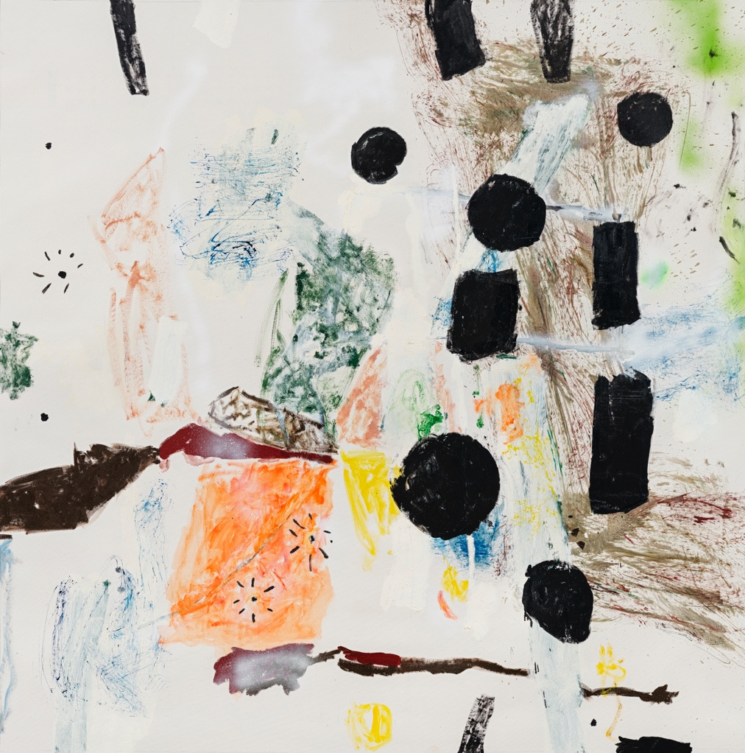

林亦軒 Lin YiHsuan, 菜鳥組曲 Yardbird Suite, 2023, 畫布油彩、噴漆 oil and spray on canvas, 150 x 148.5 cm



Reed Lee, In a Faraway Place, 1983, oil on canvas, 130 x 97 cm

A Foreign Cloud in Another Sky：Taiwan Abstraction from 1960’s  
Chen Ting-Shih Chen DeWang HsuYuJen Read Lee Lin YiHsuan Yang NaiJen  
***15 April to 24 May 2025***

Each Modern is pleased to announce " *A Foreign Cloud in Another Sky：Taiwan Abstraction from 1960’s*," scheduled for April. This exhibition begins with Chen DeWang and Chen TingShih, who operate independently of the mainstream system, alongside pioneering abstract artists Reed Lee, Hsu YuJen, Lin YiHsuan, and Yang NaiJen, who challenge existing forms and trends. It coincides with "*Gazing at the Twisting Paths Beyond：Taiwan Realism from 1960’s*" at King Car Cultural & Art Center, representing Each Modern's reinterpretation of post-war and contemporary Taiwanese art from a 21st-century perspective.

In 1948, Barnett Newman questioned how art could achieve the sublime in an era devoid of legends or myths in his famouos essay "The Sublime Is Now." The sublime has been a significant theme in Western art and religion, yet it has often been overshadowed by overthought and socialized ideas, hindering the exploration of less understood aspects. Art's inquiry into "what art is" frequently encounters repression. The long depression of European art from the 1930s to the 1950s intensified society's identity crisis, leading to the glorification of forms like neo-romanticism and symbolism. This process also existed in Taiwan, where the "Mouve Artists’ Society," founded by Chen DeWang in 1937, and its declaration to "create the painting of tomorrow and avoid following the trends" became particularly significant.

Subsequently, the rise of Abstract Expressionism and Conceptual Art in the U.S. elicited strong emotional responses through explorations of lines, shapes, and colors, creating a profound viewing experience. In this context, the influence of Eastern philosophy on experimental literature, jazz, and art movements in the 1950s and 60s—especially on the Beat Generation and abstract art—has often been underestimated, making it necessary to re-examine some connections between Eastern traditions and post-war art. In a similar historical context, Reed Li once wrote , "Behind the myriad phenomena, behind the generalized spiritual vision, one must peel back the layers, and the painting will ultimately be a line—sufficient to represent you while also distilling depth." This spectrum of being and non-being aligns with non-centralism and non-dualism in Eastern philosophy. Life and death, existence and non-existence, are two possibilities of the same process—Chen Ting-Shih, Chen DeWang, Reed Li, and Hsu YuJen have dedicated their lives to exploring East-West similarities and differences. In Chen DeWang's posthumous writings, he mentioned: "A (truly) understanding of the expressive meaning and forms of expression, techniques (including shaping techniques and material manipulation techniques) of the West, and then expressing purely from an Eastern perspective (including traditional spirit and modern environment)?"

Half a century later, in the works of Lin YiHsuan and Yang NaiJen, flowing elements—lines or painting actions—reflect contemporary artists merging inner qualities with Western techniques. Remarkably, this approach does not conform to Western self-conception but embodies a non-dualistic worldview, where existence and non-existence are two aspects of the same process. In their art, the "I" manifests a unique Eastern sensibility through cultural and technical fusion, characterized by a certain emptiness that corresponds to the real while fostering new relationships. These works represent concrete and impermanent expressions of Eastern consciousness, evolving through cultural intersections, as both artists' inner energy reaches extremes of abstraction.

Today, highly developed societies face a crisis of over-capitalization, with attacks on pioneering art emerging from the market economy. Artistic innovation has become formulaic, relying on past successes through merging, decorating, and imitating, causing art to lose its substance, and even to become kitsch or grotesque, pandering to the tasteless preferences of the masses, and catering to a sensibility that has become dull due to the abundance of existing forms and objects. We must break free from these constraints to open possibilities for freedom and decentralization through inner relationships.



Lin YiHsuan, Yardbird Suite, 2023, oil and spray on canvas, 150 x 148.5 cm