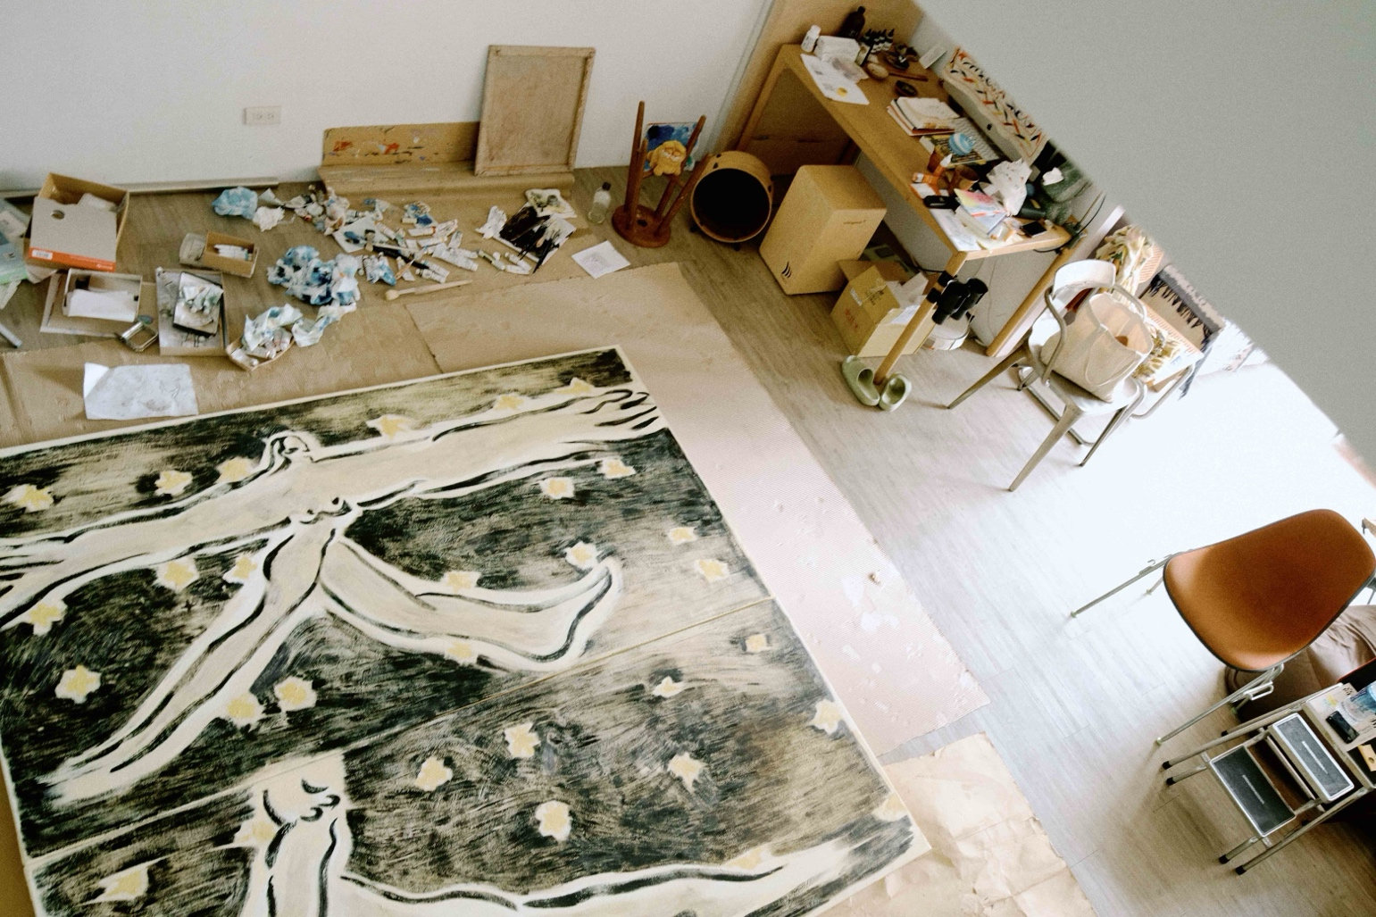  
令詠工作室，作品 《大人 Big Man》, 2024, oil on canvas, 205.5 x 215.5 x 5 cm

令  詠：肉身功課

Ling Yung：Body Lesson

**13 September - 12 October 2024**

**Opening Receptoin 13 September 5 – 7 p.m.**

Each Modern 亞紀畫廊

Body Lesson **- *藝 術 家 自 述***

今年夏天，我天天打著赤膊在工作室汗如雨下，毛孔裡滲出的汗水沿著身體曲線流下，最後在內褲頭濕成一片。原來至少要穿一件破T-shirt才比較不會失控。時而突如其來的感動或惆悵，淚水也會進來攪局。若剛好遇上生理期來就更精彩了，全身由上至下，由內而外感受著液體的湧動。日復一日，身心的細微週期變化也一起在畫布上留下了陰晴圓缺的軌跡。

我和這些體液一同地慢慢流動穿梭，體驗著不同覺受層次的生滅。身體裡有一股力量的展現叫做「韌」，介於剛和柔之間，是陰陽的交會。它不是無堅不摧，而是張弛有度。我覺得這是一個很美的境界，在肉身及精神上皆是。它渴望著延展、渴望擴張、交融，像宇宙一樣。而我們就是宇宙的縮影，既偉大又渺小。當我們感嘆著宇宙的浩瀚之時，別忘了在我們體內也存在著同一個小宇宙。〈大人〉這幅作品就是在紀錄這具肉身裡渴望延展擴大的本質。

我時常在想，一個人真的有這麼多需要去表達嗎？如果是，為何我在創作的當下時常空白？每當我回過神來，總是懷疑剛剛在操筆的人究竟是誰？

準備這次展覽作品的期間，有好一陣子我把自己活得像個山頂洞人，這也是我最平靜喜悅的時光。我將創作簡單化，回歸到一種本能。當它不再是為了表達任何頭腦想法，而是簡單到如吃喝拉撒的生理需求時，我開始感受到蘊藏在平凡之中的神性，好似伊斯蘭教裡說的：「因無形無相，而無所不在，也無始無終」。非常迷人啊！特別是當我在繪製大幅作品時，時而倒退時而跪，跪到膝蓋長小膿包才發現該去買個護膝。進退的過程中衍伸出一種三跪九叩的儀式感，每晚躺在床上的都是一具精疲力竭的身體。整日埋首於其中，不餓就不吃，累了就倒地呼呼大睡，我感到自己逐漸渺小，空間開始變大，一點一滴的找回呼吸。慢吸，屏息，筆斷，念頭還在走，意不斷，深吐，重筆，慢收，走到了筆觸的盡頭，我又再度歸零。

藝術家的每一念都是透過自己的肉身管道，成為畫布上的抑揚頓挫。我發現藝術家如同修行人，而藝術作品就是藝術家們修行的具體軌跡。蒙著雙眼向內走，直到沒有了「我」的境地。沒有了這個人，這幅作品是誰畫的一點都不重要，我逐漸愛上這種感覺，在裡面我深深地被解放。

〈野人花園〉的創作過程中，我與它之間發生前所未有的對話感。一開始我操之過急，但它不斷地告訴我說，從容的姿態是需要被等待的，用時間換來的柔軟度才禁得起無限的延展。每幅作品都像小孩一樣，是一個個被社會化前的個性原型。我從來不會知道成品的模樣，也不知道要如何下手。因此創作的前期總得花上極大的精氣神與他們磨合、對話，剩下的就順由一切自然發生。

〈雨水〉是這次最後一張完成的大幅作品。創作期間正逢台北的午後雷陣雨。沒打雷時，我會讓自己到陽台淋一場雨後再進來畫。讓身體帶著雨水的溫濕度和其跳動的頻率自自然然地進入畫布。如此重複的體驗意外的讓創作節奏一氣呵成，像是積累了兩個多月的水氣在一個午後滂沱而下。反覆地輸入、輸出之下，我和身體更近了。身體在畫畫，不是我，我是被徹底被洗刷、歸零的過客。希望觀者也能從中感受到這份沁涼透徹，好似被聖水澆灌的感覺。〈雨水〉恰好成了這段創作尾聲全身濕透的美麗句點。

這次的主題叫「肉身功課」。

我時常感到自己在都市裡住久了，身體就日漸變得像鋼筋水泥般僵硬。整座都市裡的人們都像大樓的分形一樣冰冷。這種無法延展、抒發的感覺常常讓我感到很痛苦。不僅物理上僵硬，精神上也僵硬。矯枉過正的禮數、道德法律、政治正確⋯⋯，一層又一層的頭腦思維像一道道硬殼，我們變得有點像蛤蜊，只是裡頭藏著一具萎靡不振的肉身。

純然的生命力被不斷地分析再分析。演算法、標準化及數據化。BMI、腰臀比、體脂肪⋯⋯。物質上更細微的剖析，精神上離之越遠。如本屆奧運的XY染色體話題，我認為這就是人們用理性剖析去扼殺純然生命力的一種結果。身心不二，也就是身和心互為表裡。當身體逐漸失去信仰時，同樣在我們的心裡及社會層面也會如如相應。所謂信仰是指一個生命運作的重心，一股精純的動能。精神性的花園日漸凋零，日復一日，會不會逐漸忘了去感受？忘了去感受就會忘了去愛。過度仰賴儀器的判定，人們失去了寶貴的直覺和生命力，肉身有所渴望卻不自知，我們失去了表達肉身最主觀的立場。

肉身給予我們最美的禮物就是覺受，肉身若不在，覺受也會消失。都會裡的我們其實在覺受上的發展是受到嚴重阻礙的，每天最大的眼耳鼻舌身體驗是來自整座水泥叢林的科技產品。當覺受面無法被刺激和滿足時，肉身也將隨之凋零。新時代裡，大家常常在說要做自己、愛自己，可是早已麻木的感官該怎麼「做」？該怎麼「愛」？久而久之，也只變成一個沒靈魂的口號而已，因為我們的覺受已被蒙蔽。生命想找個出口，所以就讓頭腦編出一些制式的語法試圖催眠彼此。真的很瘋狂！我們無法覺知到其實自己這麽的乾涸！

我很喜歡體驗各式傳統療法，針灸推拿、拍痧刀療、拔罐放血等。這些肉體上的體驗是我創作的泉源之一。只要保持著專注，就能平靜地走入更深的覺受面，和瑜珈精神一樣。其實在物質身之上，我們的身體還著有更精微的層面，幾乎所有古老宗派裡對此都有各自的哲理以及玩味的法門，彼此之間也都能在超越時間、空間的藩籬下相互應證著。人們發現其實肉身的可能性非常的大，大到不在現今科學理解範圍內。靠著這些精微層次的體驗，人們可以穿越一切。

比如說「痛」，這個讓眾人避之唯恐不及的覺受。現代人只要稍稍有點痛覺就習慣用止痛藥去壓抑它，因為我們已無意識將「痛」與「危險、不好」綁定在一起。但實際上覺受都是中性的，好壞依個人而訂定。痛覺是肉身和我們對話的一種語言模式，若在無意識之下用藥物壓抑了，我們就失去了和身體溝通的機會。痛覺是保障我們存亡的機制，若沒有痛覺，連斷腿了都不自知。而我們都是在母親的痛覺過程裡誕生的，古老神聖的刺青圖騰也是在痛覺裡完成祈福的。這麼說來，痛是否也很美麗？痛是可以被穿越的，所有的覺受皆是，一切都在生住異滅的定律裡。內在的我，不是被動的感受者，而是主動的體驗者。一但我們開始向內走，改寫體驗覺受的慣性迴路，才是我們和身體、和宇宙對話真正的開始。

總之，肉身的功課，就是「覺受」。

如何體驗肉身就如何面對死亡。

或許在人生的中途，就會有一部分的肉身像乘著救生艇一樣先離開這艘大船。

離開，是最後也是最難的功課。

與曾經賦予你所有體驗的載體告別，與自己的肉身告別。

因此有些文明及宗派認為活著是來練習面對死亡的。

這份功課如影隨形了我們幾千年。

從公元前的吉爾伽美什、古埃及法老、基督復活、佛陀轉世、到現在的AI機器人。

有些肉身面向冥界、有些面向來世，有負罪等待救贖的、有擁抱痛苦與狂喜的，感官縱慾的、苦行百煉的、千姿百態的肉身自洪荒以來不斷地流轉著。  
生和死或許是同一件事情。有肉身的時候，我們習慣稱之為「生」。  
肉身賦予我們覺受，而通過覺受，我們得以去超越肉身。  
它是一把珍貴的鑰匙，甚至是一切的起點。  
不管怎樣，只要活著，就永遠無法迴避這份功課。

希望有一天我們都能還至肉身的本處，靠近一點點也好。  
不帶任何評判，只有純然的體驗。  
一步步走回那方淨土，像回到故鄉一樣。

雖然真的很難。

－ 2024.08.14 令詠

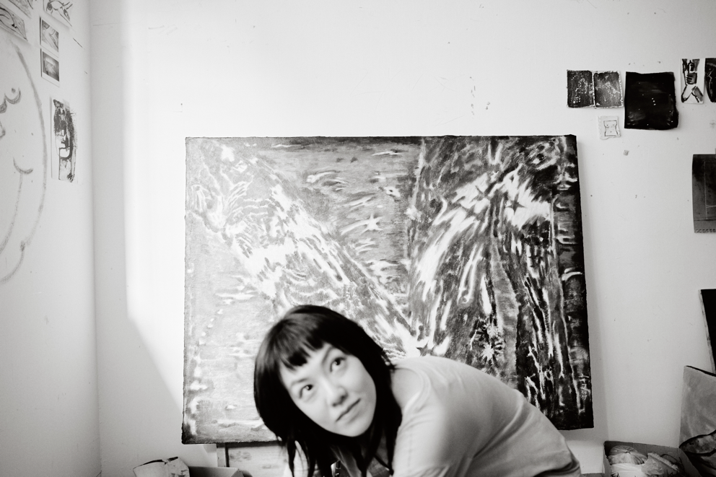  
藝術家令詠於工作室

***關 於 藝 術 家 與 展 覽***

令 詠，1992 年生，擁有服裝設計的背景，其藝術創作的特點是對細膩認知的深刻內在表現。她的畫作從人物、動物、風景和自然世界中汲取靈感，不斷蛻變，在細微的情感和神話般的抽像之間優雅地搖擺，以直觀的線條、筆觸、色彩為特色。

令詠2020年於亞紀畫廊舉辦「素顏的女人」個展，爾後參加2022年亞紀畫廊群展「盜夢者」。2024年於國際矚目的畫廊周北京舉辦個展「甲木」，為本展「肉身功課」的前傳－今年的兩次個展皆呈現令詠多件大尺幅新作、以及精巧的紙上作品。「甲木」象徵藝術家自己的生命，由天干五行隱喻藝術家對東方哲思的領悟，「肉身功課」象徵藝術家肉體與靈性的連結，承載著藝術家每刻當下、每寸身體的覺受。這些蔥鬱、充滿筆觸的畫作彷佛另一天地世界，觀者可在這些畫作中漫步欣賞—如同令詠所述，創作於她是一種「連結」，這些作品通往新時代對自然、心靈、身體的信仰渴求。

***展 覽 作 品 精 選***

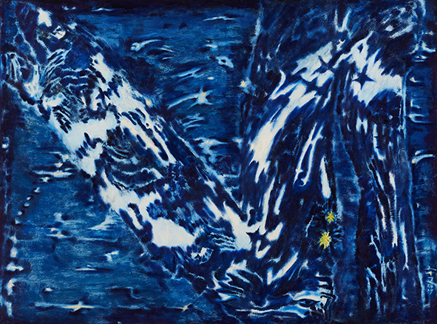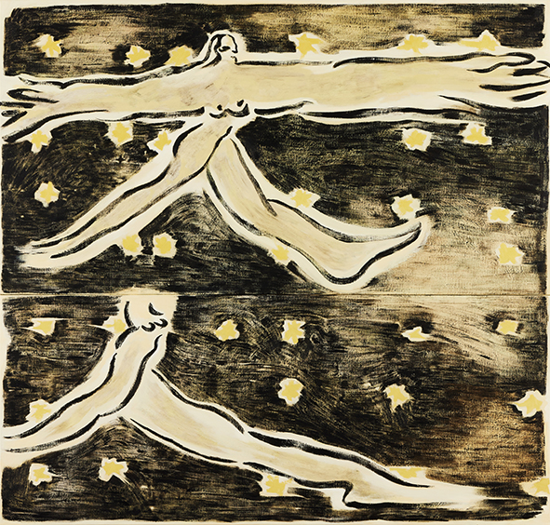

令詠 Ling Yung

大人 Big Man, 2024

油彩畫布oil on canvas

205.5 x 215.5 cm

令詠 Ling Yung

無題, 2024

油畫棒、油彩畫布oil and oil sticks on canvas

104.2 x 140 cm

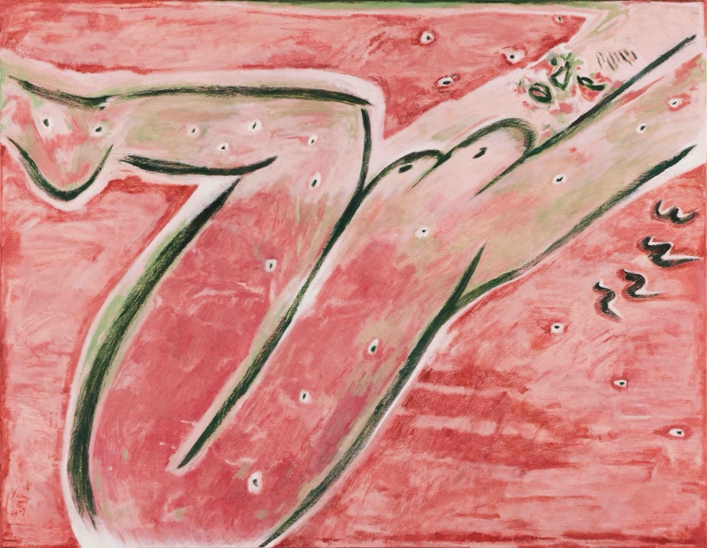

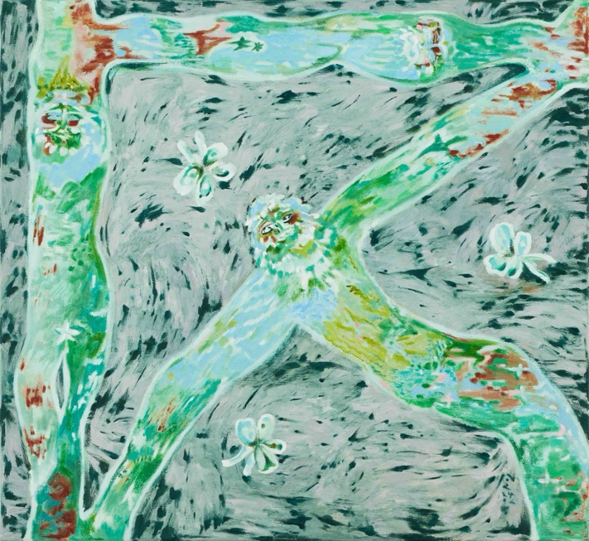

令詠 Ling Yung

西瓜女士 Lady Watermelon,2024

油彩畫布oil on canvas

140.2 x 185 cm

令詠 Ling Yung

吉爾伽美什 Gilgamesh, 2024

油彩畫布oil on canvas

110 x 120.5 cm

  
Artist studio with the work *Big Man,* 2024, oil on canvas, 205.5 x 215.5 x 5 cm

令  詠：肉身功課

Ling Yung：Body Lesson

**13 September - 12 October 2024**

**Opening Receptoin 13 September 5 – 7 p.m.**

Each Modern 亞紀畫廊

Artist Statement

Body Lesson

This summer, I found myself working in the studio, bare-shouldered and drenched in sweat, as it trickled down the curves of my body, pooling at my waist. I quickly learned that wearing at least a worn T-shirt helped me maintain some semblance of control. In moments of sudden emotion or melancholy, tears would join the mix, and during my menstrual cycle, the sensations intensified, as my entire being felt the rush of fluids from within. Each day, the subtle cyclical changes of my body and mind left their traces on the canvas.

I flow with these bodily fluids, experiencing the ebb and flow of life and death at various levels of awareness . Within the body lies a power I call " resilience," a balance between rigidity and flexibility, a convergence of yin and yang. It is not about being invincible; rather, it embodies a relaxed strength. This state is profoundly beautiful, both physically and spiritually, as it yearns to stretch, expand, and merge—much like the universe itself. We are miniature universes, both grand and insignificant. As we marvel at the cosmos, we must remember that the same universe exists within us. My work *Big Man* captures this essence of the body’s desire to expand.

I often ponder whether one person truly has so much to express. If so, why do I frequently find myself blank during the act of creation? Each time I regain my senses, I question who it was that held the brush.

In preparing for this exhibition, I embraced a primitive existence, akin to a caveman, which brought me profound peace and joy. I simplified my creative process, returning to instinct. When creation transcends the need to express intellectual ideas and becomes as fundamental as eating, drinking, and other physiological needs, I begin to sense the divinity hidden within the mundane. As articulated in Islamic thought, "There is no form and no appearance, and thus means being omnipresent, being everywhere , with no beginning and no end." This notion is captivating! Especially when working on large pieces, I would often find myself kneeling, only to realize I needed knee pads after developing small sores. The act of moving in and out of the studio took on a ritualistic quality, leaving me exhausted each night. Immersed in this process, I would eat only when hungry and sleep when tired, feeling myself shrink while the space around me expanded, gradually reclaiming my breath. I would inhale slowly, hold my breath, let the brush pause, and as thoughts continued to flow, I would exhale deeply, making bold strokes until I reached a point of stillness, returning to zero.

Every thought of an artist is channeled through the body, creating a rhythm on the canvas. I see artists as practitioners, with their artworks serving as tangible records of their journeys. To walk inward, blindfolded, until the concept of "self" dissolves. In the absence of this self, the identity of the artist becomes irrelevant. I have grown to love this feeling of liberation.

During the creation of *Caveman's Garden*, I experienced an unprecedented dialogue with the work. Initially, I was too eager, but it taught me that a calm demeanor requires patience, and that the softness gained through time can withstand infinite expansion. Each piece is like a child, an archetype of personality before socialization. I never know what the final outcome will be or how to begin. Thus, the early stages of creation demand immense energy to establish a rapport and dialogue with the work, allowing the rest to unfold naturally.

*Rain* is the last large piece I completed. Its creation coincided with an afternoon thunderstorm in Taipei. When the thunder paused, I would step onto the balcony to let the rain drench me before returning to paint. I allowed my body to absorb the warmth and humidity of the rain, its rhythm naturally translating onto the canvas. This repetitive experience unexpectedly harmonized the creative rhythm, as if the accumulated moisture of two months poured down in a single afternoon. Through this cycle of input and output, I grew closer to my body. It was the body that painted, not me; I was merely a transient being, thoroughly cleansed and reset. I hope viewers can also feel this refreshing sensation, akin to being blessed by holy water. *Rain* serves as a beautiful conclusion to this phase of my work, where I am completely soaked.

The title of the exhibition is *Body Lesson*.

Living in the city for an extended period has made my body feel as rigid as concrete. The people around me resemble the cold, fractal shapes of buildings. This inability to extend and express often brings me pain—physically and mentally. Layers of politeness, morality, legality, and political correctness create a hard shell around our minds, making us resemble clams, with only a withered body inside.

Pure vitality is continuously analyzed and re-analyzed through algorithms, standardization, and data—BMI, WHR, body fat percentages. The more we dissect the physical, the further we drift from the spiritual. The recent discussions surrounding XY chromosomes at the Olympics exemplify how rational analysis can stifle pure vitality. Body and mind are intertwined; when the body loses faith, so too does the mind and society. Faith represents the core of a life’s operation, a pure energy. As the garden of spirituality withers, we risk forgetting how to feel. If we forget to feel, we forget to love. Over-reliance on instruments for judgment leads to a loss of precious intuition and vitality, leaving us unaware of our body’s desires.

The greatest gift our physical bodies offer is awareness; without the body, awareness fades. In urban environments, our capacity for awareness is severely hindered, with our primary experiences stemming from technological products of the concrete jungle. When our senses are unfulfilled, the body withers. In this new era, we often speak of being ourselves and loving ourselves, but how can we "be" or "love" when our senses are dulled? Over time, this becomes a soulless slogan, as our awareness is obscured. Life seeks an outlet, prompting our minds to construct standardized narratives to hypnotize one another. It is a madness we fail to recognize—our own desiccation.

I find solace in traditional therapies such as acupuncture, massage, gua sha, and cupping. These physical experiences are a wellspring for my creativity. By maintaining focus, I can delve deeper into awareness, akin to the spirit of yoga. Beyond the physical, our bodies possess subtler dimensions, each ancient tradition offering its own philosophies and practices that resonate across time and space. The potential of the physical body is vast, extending beyond current scientific understanding. Through these nuanced experiences, we can traverse all boundaries.

Consider "pain," a sensation many avoid. Modern society often suppresses even minor discomfort with painkillers, unconsciously linking "pain" with "danger" and "negativity." Yet, all sensations are neutral; their value is subjective. Pain serves as a language through which the body communicates with us. Suppressing it robs us of the opportunity to engage with our bodies. Pain is a survival mechanism; without it, we might not even realize we’ve injured ourselves. We are born from our mother’s pain, and ancient sacred tattoos are often completed through the experience of pain. In this light, can pain not also be beautiful? Pain can be transcended; all sensations can be traversed, for everything abides by the law of impermanence. The inner self is not a passive recipient but an active participant. When we begin to journey inward and rewrite our habitual responses to sensation, we initiate a true dialogue with our bodies and the universe.

In essence, the work of the body is "awareness."

How we experience our physical selves reflects how we confront death.

Perhaps, midway through life, a part of our physical being will depart the ship first, like a lifeboat. Leaving is the final and most challenging lesson.

It is a farewell to the vessel that has provided all our experiences, a farewell to our physical bodies.

This is why some civilizations and philosophies view life as a practice in facing death.

This lesson has shadowed us for millennia.

From the ancient Gilgamesh, the pharaohs of Egypt, the resurrection of Christ, the reincarnation of Buddha, to today’s AI robots.

Some bodies turn toward the underworld, others toward the afterlife; some bear the weight of sin awaiting redemption, while others embrace pain and ecstasy. The myriad forms of flesh have flowed continuously since time immemorial.

Life and death may indeed be one and the same. While we possess physical bodies, we refer to it as "life."

The physical body grants us awareness, and through this awareness, we transcend the physical.

It is a precious key, the very starting point of all things.

Regardless, as long as we live, we cannot escape this lesson.

I hope that one day we can all return to our physical selves, even if just a little closer.

Without judgment, only pure experience.

Step by step, we will journey back to that pure land, as if returning home.

Though it is indeed a difficult path.

－ Ling Yung, 14 August 2024

  
Ling Yung

Each Modern is pleased to announce the first solo exhibition of Ling Yung in Taiwan, following her successful solo presentation at Gallery Weekend Beijing 2024. Born in 1992 and with a background in fashion design, Ling Yung is known for her profound inner expression and delicate perception, which permeate her artistic creations. Her paintings draw inspiration from figures, animals, landscapes, and the natural world, continuously evolving as they gracefully oscillate between subtle emotions and mythical abstraction, characterized by intuitive lines, dynamic brushstrokes, and a vibrant color palette.

Ling Yung first captured attention with her solo exhibition "A Woman Without Makeup" at Each Modern’s online viewing room in 2020, followed by her participation in the group exhibition "Paprika" at Each Modern in 2022. In 2024, she presented "As Within, So Without" during Gallery Weekend Beijing, which serves as a prelude to her upcoming exhibition in Taiwan. Both of this year's solo exhibitions feature large-scale new works alongside exquisite pieces on paper.

"As Within, So Without" symbolizes the artist's personal journey, with the heavenly stems and five elements metaphorically reflecting her understanding of Eastern philosophy. In contrast, "Body Lesson" represents the connection between the artist's body and spirit, embodying her awareness of every moment and every inch of her being.

Ling’s lush, brushstroke-filled paintings create an immersive realm, inviting viewers to wander and appreciate the depth of her work. As Ling describes, her creations serve as a form of "connection," leading to a renewed yearning for faith in nature, spirit, and the body in this new era.

Selected Works



Ling Yung

Big Man, 2024

oil on canvas

205.5 x 215.5 cm

Ling Yung

Untitled, 2024

oil and oil sticks on canvas

104.2 x 140 cm





Ling Yung

Lady Watermelon,2024

oil on canvas

140.2 x 185 cm

Ling Yung

Gilgamesh, 2024

oil on canvas

110 x 120.5 cm